Cheyenne, Wyoming REALTORS® Tammy and John Facemire Earn Military Relocation Professional (MRP) Certification
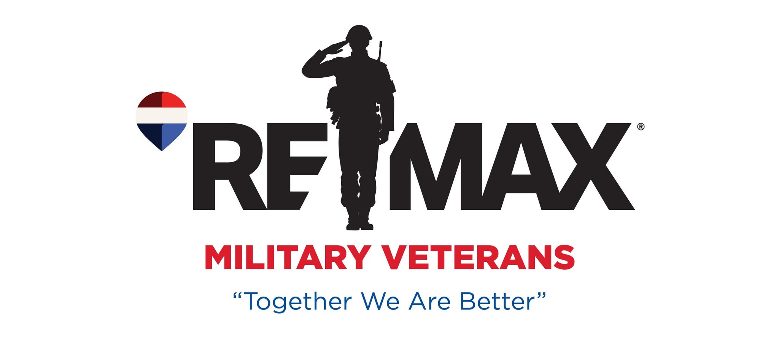
FOR IMMEDIATE RELEASE
Cheyenne, Wyoming REALTORS® Tammy and John Facemire Earn Military Relocation Professional (MRP) Certification
Tammy and John Facemire, REALTORS® with RE/MAX Capitol Properties in Cheyenne, Wyoming, have earned the Military Relocation Professional (MRP) certification, enhancing their ability to serve active-duty military members, veterans, and their families with specialized real estate expertise.
Tammy Facemire was born in Heidelberg, Germany, where her father was stationed in the U.S. Army. She later moved to upstate New York, where she attended Richfield Springs Central School, a small K–12 school her parents also attended. This close-knit environment helped shape her strong sense of community, discipline, and commitment to service.
John Facemire was born in Barberton, Ohio, and raised in West Virginia. His father was an Army veteran, which helped inspire John’s path into military service. He joined the Army National Guard prior to graduating from Gauley Bridge High School and served with the 193rd Engineer Battalion Company in Oak Hill, West Virginia. In this role, he operated heavy equipment and contributed to infrastructure development projects throughout the region.
Tammy began her military career in the United States Air Force, attending Basic Military Training at Lackland Air Force Base, Texas, before being stationed at Offutt Air Force Base in Nebraska as a Dental Assistant. Her role provided extensive experience in patient care and clinical operations supporting Airmen and their families.
John later transitioned from the Army National Guard to the United States Air Force, completing Basic Training at Lackland Air Force Base. After technical training, he was stationed at Pope Air Force Base in North Carolina as a Security Police Officer and Law Enforcement Specialist. Throughout his career, he deployed to multiple locations including Panama, Haiti, Cuba, Italy, Honduras, Qatar, and Korea.
It was at Offutt Air Force Base in Nebraska where Tammy and John met. Their shared military background and commitment to service formed the foundation of their relationship. They married and built a blended family of six children: Samantha, AJ, Shelby, Cody, Trinity, and Owen.
The Facemires later relocated to Colorado, where Tammy was stationed at Peterson Air Force Base and Schriever Air Force Base prior to transitioning into civil service. She joined the United States Air Force Academy Dental Clinic, where she worked in the Dental Residency Program. In this role, she supported advanced training for Air Force dentists in specialized areas and helped coordinate care for active-duty members, retirees, cadets, and their families.
During this time, John continued to serve in key leadership roles. He was stationed at Buckley Air Force Base in Aurora, Colorado, where he served as a Flight Chief and Security Force Training Instructor. He was then assigned to Peterson Air Force Base, where he served as a First Sergeant, followed by an assignment to the United States Air Force Academy’s 10th Medical Group, where he also served as a First Sergeant.
While stationed in Colorado Springs, the Facemires purchased their first home using a VA loan—an experience that would later influence their passion for helping military families navigate the homebuying process.
From the United States Air Force Academy, the family relocated to Kirtland Air Force Base in New Mexico. During this time, Tammy furthered her education and earned her Bachelor of Science degree in Project Management, with a minor in Small Business Management, from Embry-Riddle Aeronautical University.
The family later relocated to F.E. Warren Air Force Base in Cheyenne, Wyoming. It was here that Tammy obtained her real estate license and began her career with RE/MAX Capitol Properties. After John retired from the Air Force as a Chief Master Sergeant (E-9) following 32 years of distinguished service, he joined Tammy in the business, bringing decades of leadership experience and a deep understanding of military life.
As veterans, Tammy and John offer a unique and valuable perspective to their clients. Their Military Relocation Professional (MRP) certification reflects their continued commitment to serving military members and their families with expertise and care. The designation provides specialized training in navigating PCS moves, understanding housing allowances, and working with VA loan benefits.
“We understand the challenges that come with military relocations because we’ve lived it,” said Tammy. “It’s an honor to help fellow service members, veterans, and their families through one of the most important decisions of their lives.”
Their business is built on professionalism, integrity, and personalized service. Tammy and John take pride in guiding their clients through each step of the real estate process, ensuring a smooth and informed experience from start to finish.
Many of their clients remain in touch long after their transactions are complete, forming lasting relationships and friendships that reflect the trust and care they bring to their work.
Now proud members of the Cheyenne community, the Facemires enjoy the lifestyle and opportunities the region provides. They appreciate the outdoors and spend their free time fishing, hiking, camping, and exploring the surrounding areas. They proudly serve Cheyenne, Laramie, Burns, Pine Bluffs, and F.E. Warren Air Force Base.
With a combined background in military service and real estate, Tammy and John Facemire are uniquely positioned to support buyers and sellers—especially those connected to the military—with knowledgeable, dedicated, and trustworthy service.
For more information, please visit:
https://www.remax.com/real-estate-agents/tammy-facemire-cheyenne-wy/101930142
https://www.facebook.com/JTFacemireRealty
https://www.instagram.com/tammyfacemire/
https://tammy.cheyennehomestore.com
https://www.realtor.com/realestateagents/58ff49fc3afa420010d5e16d
https://www.zillow.com/profile/Facemire%20Tammy
https://www.linkedin.com/in/tammy-facemire-1148ab80
Video: https://www.youtube.com/watch?v=-kE1wVUQl8s
Media Contact:
Tammy and John Facemire
(307) 631-8621
RE/MAX Capitol Properties
facemire.tammy@gmail.com

